Front End web training

HTML 5

Boilerplate

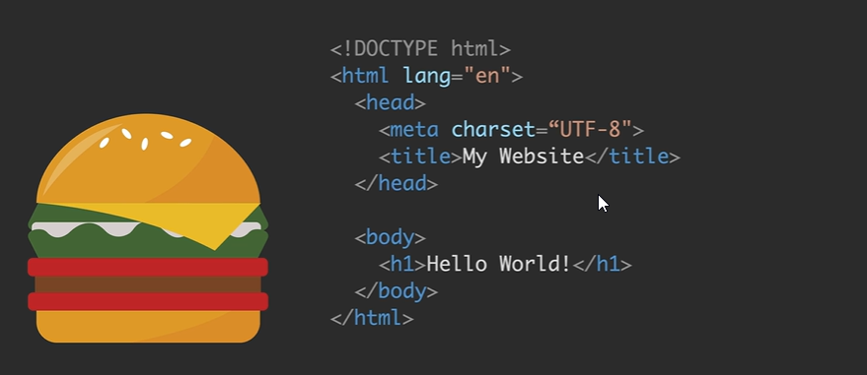

CSS External source

Inline CSS

<h1 style=”color:red”> </h1>

Internal CSS

<head>

<style>

H1{

Color: blue

}

</style>

</head>

CSS Selectors

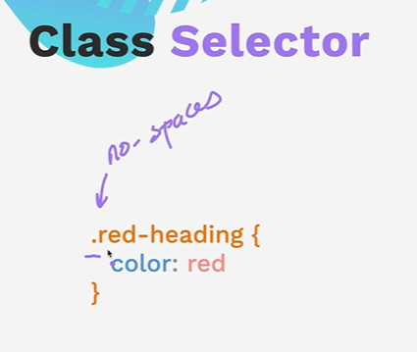

CSS Colors

Html{

Background-clor: red

}

H1{

Color: blue

}

Font size

CSS Box model

CSS Specificity

Id, attr, class, element

